Janis Gonzalez

WEB 420 RESTful APIs

Assignment 9.2 Capstone

May 14,2023

Bellevue University

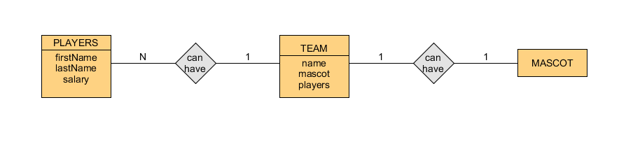

|  |  |  |
| --- | --- | --- |
| name | mascot | lastName |
| Mordor Eagles | Great Eagle | Oakenshield |

|  |  |  |
| --- | --- | --- |
| firstName | lastName | salary |
| Thorin | Oakenshield | 755,000 |